**Department of Computer Science**

**Pak-Austria Fachhochschule: Institute of Applied Sciences and Technology, Haripur, Pakistan**

**COMP-261L Computer Organization & Assembly Language Lab**

**Lab Report: 01**

**Class: BS Computer Science**

**Name: Ahmed Raza**

**Registration No.: B20F0436CS031**

**Semester: 3rd**

**Submission Date: 21 Oct, 2021**

**Submitted to: Lab Engr. Rafi Ullah**

**__________________**

**Instructor Signature**

**Lab Tasks:**

**Lab Task 01:**

Write the following assembly program in the editor of EMU8086 and assemble it.

MOV AX, 4566H

MOV BX, 0ABCDH

MOV AX, BX

MOV SI, BX

Emulate the program and discuss the results with the instructor.

**Code:**

org 100h //Origin in Memory where it starts

MOV AX, 4566H //Move Value 4566H into AX Register

MOV BX, 0ABCDH //Move Value 0ABCDH into BX Register

MOV AX, BX //Move BX into AX Register

MOV SI, BX //Move BX into SI Register

Ret

**Output:**

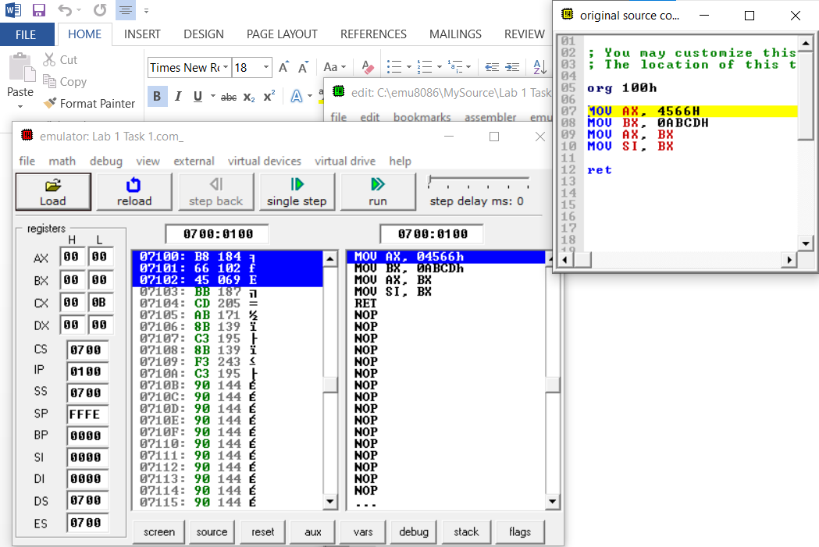

**Results & Observations:**

Inn this lab we practice on software emu8086 and try to learn about syntax of Assembly language. Along with syntax we learn Asembler directives, and also how to define array and variables and constants in assembly language. We practice some problems for better understandings and we learn a lot from them.